**COAL LAB 4, 23k-0842, KINZA AFZAL, SEC: J**

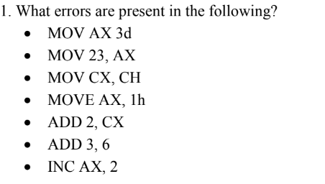

MOV AX 3d [error: no comma present]

Correction: MOV AX, 3d

MOV 23, AX [error: The first operand should be a register or a variable not an immediate value. You cannot move a value directly into an immediate.]

Correction: MOV AX, 23

MOV CX, CH [error: Both registers do not have same size. CX is a 16-bit register, while CH is only 8-bit register.]

Correction: MOV CX, AX (or any 8-bit register)

MOVE AX, 1h [error: MOVE is not a valid assembly instruction (it should be MOV).]

Correction: MOV AX, 1h

ADD 2, CX [error: The first operand must be a register or memory location, but 2 is an immediate value.]

Correction: ADD CX, 2

ADD 3, 6 [error: Both operands are immediate values, which is invalid. One operand must be a register or memory location.]

Correction: ADD AX, 6

INC AX, 2 [error: The INC instruction cannot take two operands; it can only increment by 1.]

Correction: INC AX

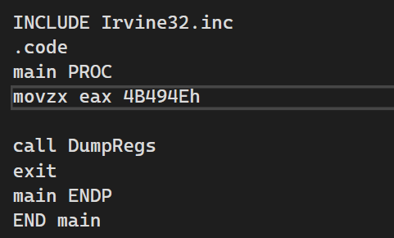

ASCII code for K is 4B, for I is 49 and for N is 4E.

